Adapting Interaction Analysis to Support Evaluation and Regulation:
A Case Study

José Antonio Marcos | Alejandra Martínez | Yannis Dimitriadis | Rocío Anguita
Computer Science E. | Computer Science E. | Telecommunations E. | Faculty of Education
Univ. of Valladolid | Univ. of Valladolid | Univ. of Valladolid | Univ. of Valladolid
jamarcos@infor.uva.es | amartine@infor.uva.es | yannis@tel.uva.es | rocioan@doe.uva.es

Abstract

Interaction analysis has become a basic function in the field of collaborative learning, as a means for supporting both regulation and evaluation of collaborative learning processes. In spite of the fact that these processes rely on the same basic functionalities, there is a lack of proposals or systems that integrate them. The most outstanding difference between the tools that support either of the approaches is that they are oriented to different types of users. Then, an interaction analysis tool able to adapt to different roles would be able to perform both functionalities. This paper presents an experience performed in an authentic learning scenario using interaction analysis for supporting regulation for students and evaluation for teachers adapting its functionality depending on analysis needs of teacher and learners that participate in the activity. A first evaluation carried out shows that the participants assess positively this experience and consider the information received easy to understand, reliable, useful and capable to modify their way of collaboration.

1. Introduction

Interaction analysis supports different functionalities, such us evaluation and regulation of learning in general, and of collaborative learning processes in particular. We refer to regulation as a scaffolding process that supports the participants’ actions in order to improve the collaborative learning experiences, and evaluation as a procedure to understand the process of learning and therefore suggest improvements (i.e. as a formative tool).
According to the model of the collaboration management cycle [13] the phases needed to perform these two functionalities in Computer Supported Collaborative Learning (CSCL) contexts are very similar, at least from a theoretical perspective. A revision of interaction analysis tools in the area of CSCL shows that several proposals exist whose functionalities could be applied for one or another purpose [1],[9]. For example, some authors state that the data obtained by the teacher in an evaluation tool could be used to support students’ self-regulation [2].
Nevertheless, these two approaches have so far been considered separately, as it can be observed by the lack of methods and tools that integrate them. Why? We argue that the main difference between the two approaches relies on the roles played by the actors to which these functions (and the corresponding tools) are oriented [7]. While regulation refers to the students, evaluation is mostly performed by a teacher. Then, a tool able to adapt to different roles should be able to perform both functionalities.
On the other hand, roles are important within CSCL activities [11], and therefore constitute an important factor for a successful application of interaction analysis tools. Although some theoretical proposals already exist in the literature, there is an urgent need for validation and feedback based on authentic situations [3].
Following these approaches, this paper presents an experience performed in an authentic CSCL scenario using interaction analysis for the detection of roles and for supporting both regulation for students as well as evaluation for teachers. Also we present initial results corresponding to subjective views of the participants.
The rest of the paper is structured as follows: The next section outlines our background in this research. Section 3 describes the application of an interaction analysis tool to a real learning scenario for supporting evaluation and regulation. The paper concludes presenting the main results and an overview of our future plans related to these topics.

2. General approach

A main research effort of our interdisciplinary group has been the development of a system for supporting formative evaluation in CSCL settings. In order to meet this aim, we proposed the Mixed Evaluation Method [10], which defines a general approach oriented to support the formative evaluation of participatory aspects of collaborative learning in authentic learning scenarios.
This method is partially supported by an interaction analysis tool called SAMSA that builds social networks representing the interaction among the users of a CSCL environment; and computes a set of social network analysis indexes that measure individuals’ participation and groups’ collaboration structures [10]. These indexes and networks are shown to the users for later analysis. Although this tool was designed to be used to support formative evaluation by teachers and researchers, its use showed that it might be useful to support students’ self-evaluation [10]. For example, if SAMSA can help a teacher to detect isolated students in an intermediate evaluation, it could send also this information as feedback to the implied students so that they are able to regulate their work. However, these types of users have different needs. A teacher will require different information than a K-12 student (e.g., different contents or formats of presentation). Besides, an actor can change dynamically roles during the collaboration. For example, the teacher’s role could move progressively from group leader to facilitator, and finally, take up the role of observer. These roles require also different types of support [12].
Thus, it could be very useful to identify the roles that can appear in the collaborative process and their interaction analysis needs, i.e., what information is necessary and what is the way to present it to the users [7]. A similar approach can be found in the effort to adapt awareness tools to different users in the CSCW field [4],[5].
On the other hand, this adaptable support requires that interaction analysis tools interpret and manage computationally these aspects. To reach this goal, we have proposed a framework for the structured description of roles, including the specification of their interaction analysis needs and the definition of indicators and values capable to identify these roles dynamically [8].

3. A case study: adapting interaction analysis tool for evaluation and regulation

This section presents the first results extracted from a case study that is taking place since February 2005 in the course of “ICT (Information and Communication Technologies) applied in Education” at the University of Valladolid, Spain. The course involves forty seven students distributed into eleven groups. It is divided into two main phases: First, a theoretical phase when students have to analyze different aspects of the subject and elaborate in groups a final report; and later, a practical phase, when students have to create a Webquest, that could be eventually used in a real school, designing as well the ICT resources that will support such a didactic unit. The setting is a blended one, where face-to-face activities are interleaved with technology-supported in-site or distance activities. Students collaborate mainly using Synergeia [6], a tool that provides a workspace for sharing documents among all the actors implied in the course.
SAMSA has been employed for supporting regulation for the students and evaluation for the teachers, and the aforementioned framework for the description of roles was used to describe the interaction analysis needs of teachers and students. Table 1 shows these needs, according to the five dimensions defined in the framework: purpose, content, type and presentation of information, and frequency of feedback.

Table 1: IA needs specified for the teacher and learner roles and their values for the case study
Dimension | Roles
Dimension | Teacher | Learner
Purpose | Evaluation  - Intermediate and final | Self -Regulation
Content | Individual participatory aspects:
Content | - into the group  - with rest of learners  - comparative by phases | - into the group  - with rest of learners
Type | Numerical / graphical | Graphical
Presentation | - Sociogram  - SNA indexes: degree, closeness, centralization | - Sociogram + main concepts about how interpret it
Frequency of feedback | Milestones  - Theoretical phase  - Practical phase | Milestones  - Theoretical phase

The students of this course do not have previous collaborative learning experiences using computers, while the teachers are more experienced in the use of interaction analysis tools for evaluation. For this reason, the information specified for the teacher role included more complex data than the information provided for learners. Concretely, learners received only elementary sociograms, which are graphs that represent the members of a group as nodes and the relationships among them as lines in the graph. In our case study we have considered the relationships composed by the indirect links between an actor that creates an object in the Synergeia workspace and those that access this object in order to read it or modify it. The visualization of the structures of students’ actions, by means of a suitable representation, can assist students develop meta-cognitive mental action and subsequently regulate their collaborative activity [12].
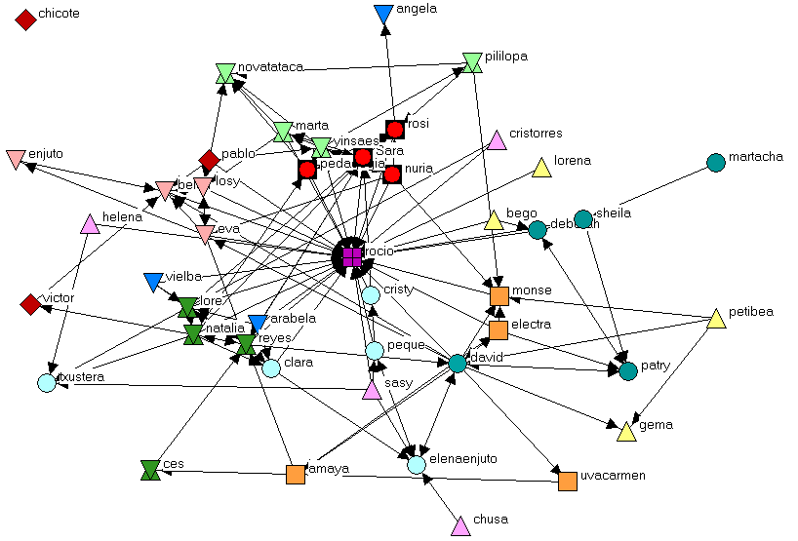
Besides the sociograms, information for teachers included also numerical information based on social network analysis indexes. Concretely, the degree centrality, closeness centrality and degree centralization were selected [14]. The degree centrality measures the activity and the participation of an actor in the network. In the case of relationships that consider the direction of the link, two indexes are defined: indegree, or the number of links terminating at the node; and outdegree, or the number of links originating at the node. On the other hand, the closeness centrality specifies the proximity of a node to the rest of nodes in the network. This index can be interpreted as a measurement of the influence of an actor in the overall network. Finally, the degree centralization gives an idea of the dependency of the network on a small number of actors.

3.1. Supporting regulation

According to the interaction analysis needs specified for the learner role in Table 1, the information obtained with SAMSA for supporting regulation included individual participatory aspects of learners, and it should be presented graphically using elementary sociograms. Figure 1 shows an example of such a sociogram, which was in fact sent to each member of one of the groups (group 5).
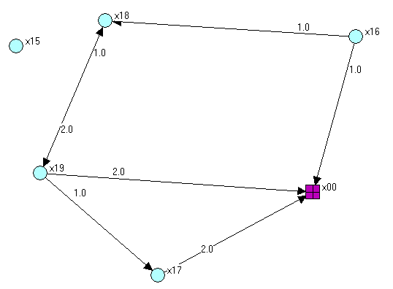

Figure 1: Sociogram associated with students of group5, denoted by round nodes, and including the teacher (a square node)

These sociograms support the members of each group to visualize graphically their activity within the group during development of theoretical final report.
In order to facilitate the understanding of the sociograms, the report sent to the learners also included a previous section with the most elementary concepts about how to interpret a sociogram. This is a key aspect to achieve learners’ reflection and regulation about their collaborative activity. For example, it is not difficult to interpret that learner “x15” is an isolate node of group 5, and does not collaborate with the rest.
Figure 2 shows a second sociogram delivered to learners. This sociogram shows the individual activity of each learner with respect to the rest of participants in this course. For example it is possible to observe that the aforementioned learner “x15” is linked to four members of other groups, but he/she does not collaborate with the members of his/her group.

Figure 2: Sociogram associated with all participants during the task of elaboration of theoretical final report, where each group is differentiated by the form and colour of their members.

3.2. Supporting evaluation

According to the interaction analysis needs specified for the teacher role in Table 1, the information obtained through interaction analysis with SAMSA was oriented to support intermediate and final evaluation for teacher, included the sociograms incorporated in learners’ report as well as numerical information based on the indexes described at the beginning of this section.
Table 2 shows the numerical information delivered to the teacher, obtained from the activity of members of group 4 during the last phase of the course, where learners create Webquests in group.

Table 2: SNA indexes obtained from members of group 4 during the practical phase of this course
 | ACTOR | Indegree | Outdegree | Incloseness | Outcloseness
 | x11 | 2 | 2 | 75,00 | 42,86
 | x12 | 7 | 9 | 75,00 | 42,86
 | x13 | 13 | 4 | 100,00 | 50,00
 | x14 | 0 | 7 | 25,00 | 100,00
Centralization: 333,33% (indegree); 155,56% (outdegree)

For example, it is possible to observe that the learner “x13” has an incloseness value of 100. This means that all members of her group have read some of her documents using the Synergeia workspace, and therefore, she can be regarded as a prominent learner for her colleagues.
The teacher also receives comparative data about the activity of each participant into his/her group and with learners of other groups. In Table 3 we can see the data obtained in the intermediate evaluation of two groups. For example, it is easy to note that the members of group 10 did not collaborate among them, but they collaborated with learners of other groups. The teacher can use this information to identify group breakdowns. Concretely, in this case, the teacher offered the possibility to change their composition to the groups showing any type of dysfunction.

Table 3: Indegree and outdegree into the group and with others
 |  | Into the group |  | With other groups
 | ACTOR | Indegree | Outdegree | Indegree | Outdegree
Group 8 | x29 | 1 | 6 | 3 | 3
Group 8 | x30 | 6 | 1 | 2 | 1
Group 8 | x31 | 2 | 8 | 2 | 3
Group 8 | x32 | 2 | 5 | 5 | 3
Group 10 | x37 | 0 | 0 | 0 | 0
Group 10 | x38 | 0 | 0 | 1 | 3
Group 10 | x39 | 0 | 0 | 0 | 5
Group 10 | x40 | 0 | 0 | 2 | 3

Finally, information referred to individual and group evolution in the collaboration mediated by Synergeia was given to the teacher for final evaluation. Table 4 shows an example of indegree and outdegree data obtained from members of two groups and the teacher in the milestones fixed previously.

Table 4: Indegree and outdegree in different phases of activity
 |  | Practical phase |  | Theoretical phase
 | ACTOR | Indegree | outdegree | indegree | Outdegree
Teacher | x00 | 358 | 51 | 86 | 0
Group 4 | x11 | 0 | 4 | 5 | 0
Group 4 | x12 | 2 | 2 | 1 | 0
Group 4 | x13 | 26 | 15 | 0 | 11
Group 4 | x14 | 1 | 39 | 0 | 6
Group 7 | x24 | 7 | 22 | 5 | 0
Group 7 | x25 | 9 | 7 | 2 | 2
Group 7 | x26 | 18 | 42 | 5 | 6
Group 7 | x27 | 21 | 29 | 3 | 9

The teacher could verify the progress in the collaborative activity of the different groups. In this case, the majority of learners improved notably their first results.

3.3. Validation

In order to validate the success of this approach we have triangulated information collected by different sources of data, including interviews with the teacher and the learners, focus groups of volunteers (held twice after delivering them information about regulation) and observations in the classroom (eight sessions). This evaluation is based on the Mixed Evaluation Method [10], already applied for formative evaluation in other authentic experiences.
After we delivered the information for regulation to the students, we carried out interviews to seven groups, with a total of thirty students in order to collect their opinions about the information provided for their regulation. These interviews included the following five aspects: level of difficulty to understand the information, interest and utility, reliability with respect to the work mediated by the Synergeia workspace, how this information could affect the work into the group and finally proposals of improvement of the information that was given to them.
The results obtained were very positive. 100% of the participants answered that the information received had been easy to understand. 86% of the participants coincided that this information had been interesting and useful, emphasizing the reflection and debate that begun in the group after its reception. This aspect was also denoted by observations in classroom. In addition, the participants considered reliable the sociograms because they reflected well the main characteristics of their group work mediated by Synergeia. The rest of the students (14%) did not see their activity properly reflected, mainly because they had used magnetic disks to exchange information, and therefore the sociograms did not show all the work carried out by the group.
A very positive aspect is that the teacher and groups proposed improvements to the information that was given to them. For example, the 33% of participants suggest adding the relations of each actor with himself, because they work in many occasions on their own documents and this aspect could serve to know better this activity. Other 33% suggest analyzing larger periods of time. Finally other 33% propose to analyze separately the interactions during the laboratory hours, and out of these hours. These proposals were also assessed positively by teacher, and will be included in our next studies, as part of the formative refinement of the method and the tools.

4. Conclusions and future work

This paper has presented an experience performed in an authentic learning scenario using interaction analysis information obtained with SAMSA for supporting evaluation for teachers as well as regulation for students, adapting it to the specific needs for both roles, which have been described with the help of a framework for the description of roles.

The participants of this experience have assessed it positively and they consider that the information received was easy to understand, reliable, useful and capable to modify their collaborative activities, and to achieve self-regulation. We have obtained these conclusions based on the collected information from different sources of data as interviews to the participants, observations in the classroom and focus group. In order to evaluate the effects of the feedback delivered to participants we are currently analysing the changes observed in the activity of these students after the reception of the sociograms.
The paper also describes the application of the framework for the description of roles proposed in [8] for defining and characterizing the roles of the teacher and the learners in this scenario. This framework provides a description of the initial pre-established roles and information needs. Future work plans include adding the specification of indicators and values necessary for detecting dynamically changes of roles. This is an important feature to advance towards the design of usable, configurable and adaptable interaction analysis tools able to detect roles dynamically and adapt their functionalities automatically to the needs specified for them.

Acknowledgements

This work has been partially funded by e-Learning TELL project EAC/61/03/GR009, Kaleidoscope NoE FP6-2002-IST-507838, Spanish Ministry of Science and Technology TIC-2002-04258-C03-02 and the Autonomous Government of Castilla and León (project VA009A05). The authors would also like to thank the rest of GSIC/EMIC Group at the University of Valladolid for their support and ideas.

References

[1] Avouris, N. & Komis, V. (2002). "OCAF:An Object-Oriented Model of Analysis of Collaborative Problem Solving". Proceedings of International Conference on CSCL. Colorado, G.Stahl (ed)Lawrence Erlbaum Associates.

[2] Avouris, N., Komis, V., Fiotakis, G., Margaritis, M., & Tselios, N. (2003). "Tools for Interaction and Collaboration Analysis of Learning Activities". Proceedings of the 6th CBLIS Conference. Nicosia, Greece.

[3] Dimitracopoulou A. & Petrou A. (2003). “Advanced Collaborative Learning Systems for young students: Design issues and current trends on new cognitive and metacognitive tools”. In THEMES in Education International Journal; 60 p.

[4] Dourish, P. & Belloti, V. (1992). "Awareness and Coordination in Shared Workspaces". Proceedings of the Computer Support for Collaborative Working (CSCW) Conference. Toronto, Canadá, ACM Press.

[5] Drury, J. & Williams, M.G. (2002). "A Framework for Role-Based Specification and Evaluation of Awareness Support in Synchronous Collaborative Applications". Proceedings of the 11th International Workshops on Enabling Technologies for Collaborative Enterprises (WETICE02). Pittsburgh, IEEE Computer Society Press.

[6] ITCOLE Research Project. (2005). "Synergeia Website." Retrieved in December, 2005 from http://bscl.gmd.de.

[7] Marcos, J.A. , Martínez, A., & Dimitriadis, Y. (2004). "Towards the Integration of Evaluation and Regulation With a Role-Based Approach". Proceedings of Workshop on "Interaction Analysis Supporting Participants During Technology-Based Collaborative Activities". CSCL Symposium, Kaleidoscope Noe. Lausanne, Switzerland.

[8] Marcos, J.A. , Martínez, A., & Dimitriadis, Y. (2005). "Towards Adaptable Interaction Analysis Tools in CSCL". Proceedings of 12th AIED International Conference . Workshop on Representing and Analysing Collaborative Interactions. Amsterdam, the Netherlands. pp. 70-74

[9] Martinez, A. , Dimitriadis, Y., Gomez, E., Rubia, B., & de la Fuente, P. (2003). "Combining Qualitative and Social Network Analysis for the Study of Classroom Social Interactions". Computers and Education, Special Issue on Documenting Collaborative Interactions: Issues and Approaches, vol. 41, no. 4, pp. 353-68.

[10] Martínez, A., Dimitriadis, Y., & de la Fuente, P. (2003). "Interaction Analysis for Formative Evaluation in CSCL". Computers and Education. Toward a Lifelong Learning Society, (M. Llamas, M.J. Fernandez, L.E. Anido ed). pp. 227-38. Kluwer Academic.

[11] Mizoguchi, R. & Inaba, A. (2004). "Learners' Roles and Predictable Educational Benefits in Collaborative Learning. An Ontological Approach to Support Design and Analysis of CSCL.". Proceedings of 7th International Conference, ITS 2004. Maceió, Brazil, J.C. Lester et al. (ed). pp. 285-294

[12] Petrou, A. & Dimitracopoulou, A.(2003): “Is synchronous computer mediated collaborative problem solving 'justified' only when by distance? Teachers' point of views and interventions with co-located groups during every day class activities”. CSCL 2003. In (Ed) U. Hoppe. 14-18 June 2003, Bergen, Norway.

[13] Soller, A., Martínez, A., Jermann, P., & Muehlenbrock, M. (2005). "From Mirroring to Guiding: A Review of State of the Art Technology for Supporting Collaborative Learning." International Journal on Artificial Intelligence in Education. 15(4), 261-90

[14] Wasserman, S., & Faust, K.(1994): “Social Network Analysis: Methods and Applications”.Cambridge Univ. Press

